**Match Method Parameter Types Overview**

**Match on Parameters**:

**For param-pattern**:

* () - matches a method with no arguments
* (*) - matches a method with one argument of any type
* (..) - matches a method with 0 or more arguments of any type

**Match on method parameters**:

**a) Match addAccount methods with no arguments**

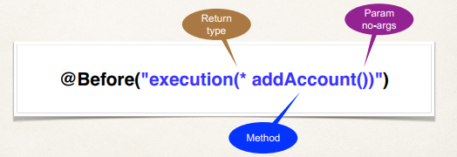

Here return type * means any return type.

**b) Match addAccount methods that have Account param**

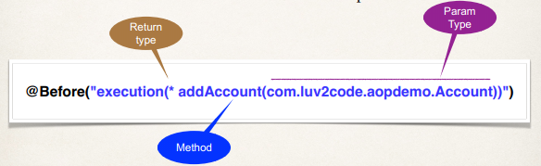

Here "com.luv2code.aopdemo.Account" is full qualified name of Account class. Fully qualified name manse class name with corresponding package name.

**c) Match addAccount methods with any number of arguments**

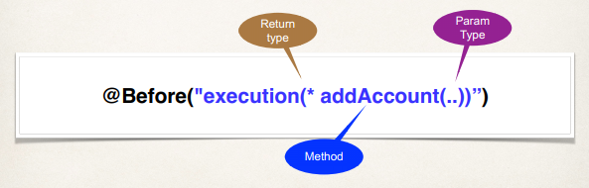

**Match on Package**:

**Match any method in our DAO package: com.luv2code.aopdemo.dao**

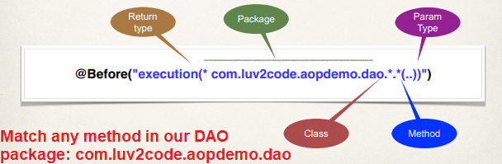

37.1. Match Method Parameter Types Overview